- CUCM End User
Create an End User and set a password, keep all other configuration in the End User page as default, no roles, no device associations etc. required. If you have an active LDAP user, you may go ahead and use it.
For this particular post, I’m creating a Local User (Mary.Winn) in CUCM.
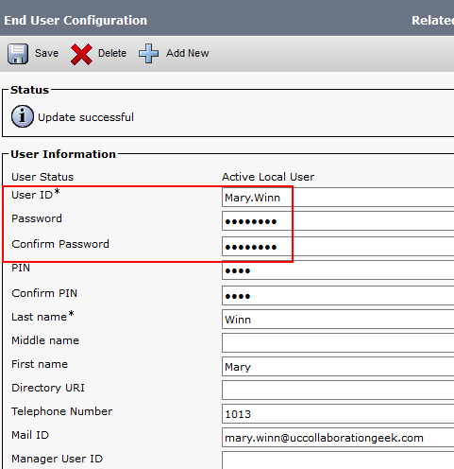

- Add 3rd Party SIP Device Basic or Advanced
Go to Device >> Phones >> Add New
Select Phone Type as Third-Party SIP Device (Basic) and click Next. Basic only allows for a maximum of two calls, configure Advanced for more line capability.
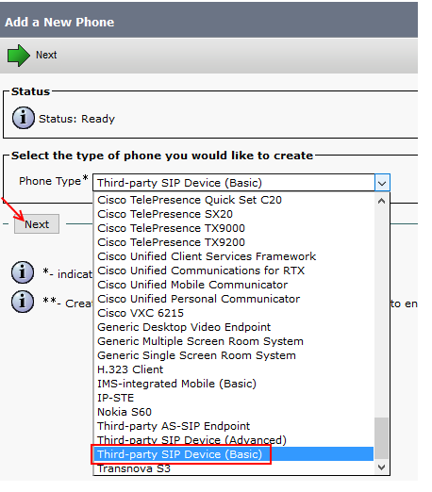
Since MAC Address is a mandatory parameter, enter a DUMMY MAC address, in my example I have used AAAAAAAAAAA1 (it should be 12 Hexa Decimal values)
Configure other parameters as shown in below figure.
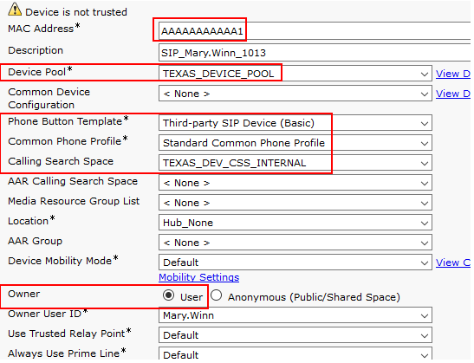
[Note: Owner and Owner User ID is an optional step only, it is not necessary to select Owner and owner User ID. But in real time we do associate a phone with specific end user to maintain the licenses]

Scroll down a little and look for Protocol Specific Information.
- Device Security Profile : Third-party SIP Device Basic Standard SIP Non-Secure Profile
- SIP Profile : Standard SIP Profile
- Digest User : Mary.Winn
[Note: This user would authenticate with Call Manager or LDAP server and get the device registered.]
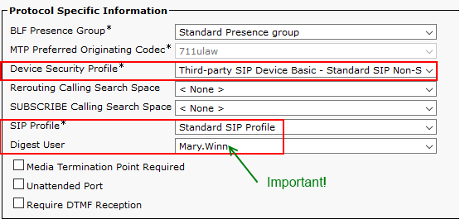

- Configure Line for 3rd Party SIP Phone
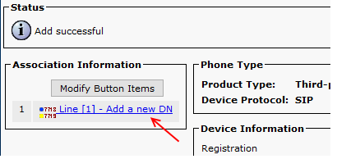

Enter the required Directory Number, Partition, Description etc.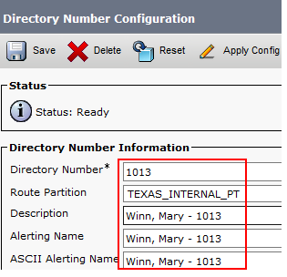
Device Configuration on CUCM is over.

- Configure SIP Tester UAC Registration
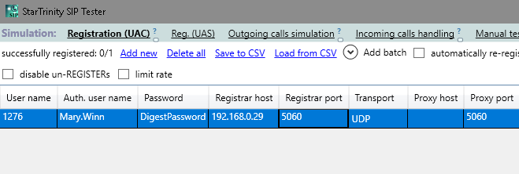
For the fields above enter the following information
User Name: Extension assigned to Line in Step 3.
Auth User Name: User ID of CUCM End User in Step 1
Password: End User Password of UserID/ (or LDAP Password of User ID) from Step 1
Registrar Host: CUCM IP Address

-All other settings are default, press re-register and you should receive a 200 OK green message.

The document will be extended. In case of multiple extensions registered to CUCM, it needs setting of "localsipportrange" in sip tester global settings. Each registration should use its own unique local UDP SIP port

